Preyasi Gaur

705704939

Problem Set 4 - Coding

**4 Implementation: Clustering and PCA**

1. a. 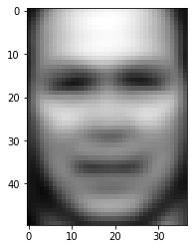The “average” face above is so blurry that we cannot identify who the face belongs to. Although we can tell that it is a face, as we can blurry outlines of facial features, we cannot see the features that will help us identify a face, like eyes, nose and mouth.   
     
   b.   
   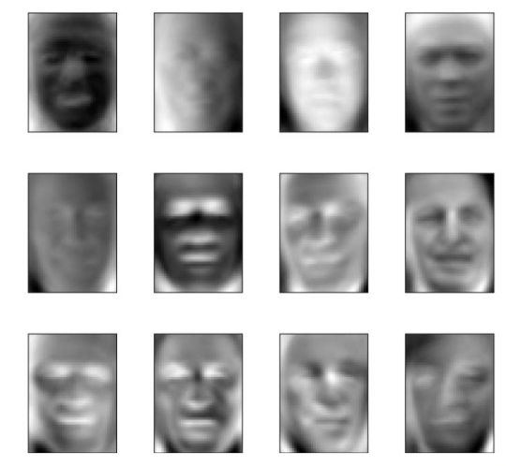  
   The top twelve eigenfaces are blurry and are not distinguishable in terms of the identities. They vary in small ways and you can tell that they are different faces, yet they all are similar in the sense that their eyes, noses, and mouths are not defined. They each have different shades of light on their face, some with more shadows and brighter eye sockets, whereas others have whiter highlights on their face and their eye sockets are darker. I think that these photos were selected as the top eigenfaces because they are the best representation of the training data. Because each of these faces vary in one way or another, they represent the diversity of the many training examples. In terms of basis vectors, these 12 eigenfaces have the top 12 highest variances.

c. L = 1  
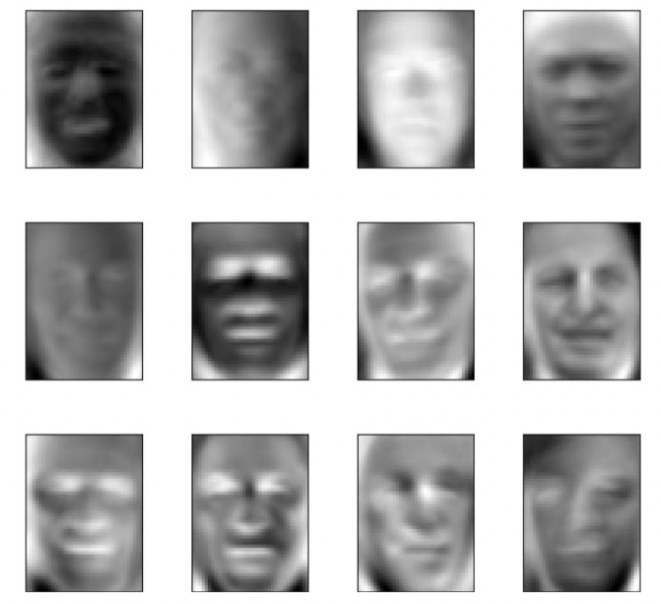

L = 10  
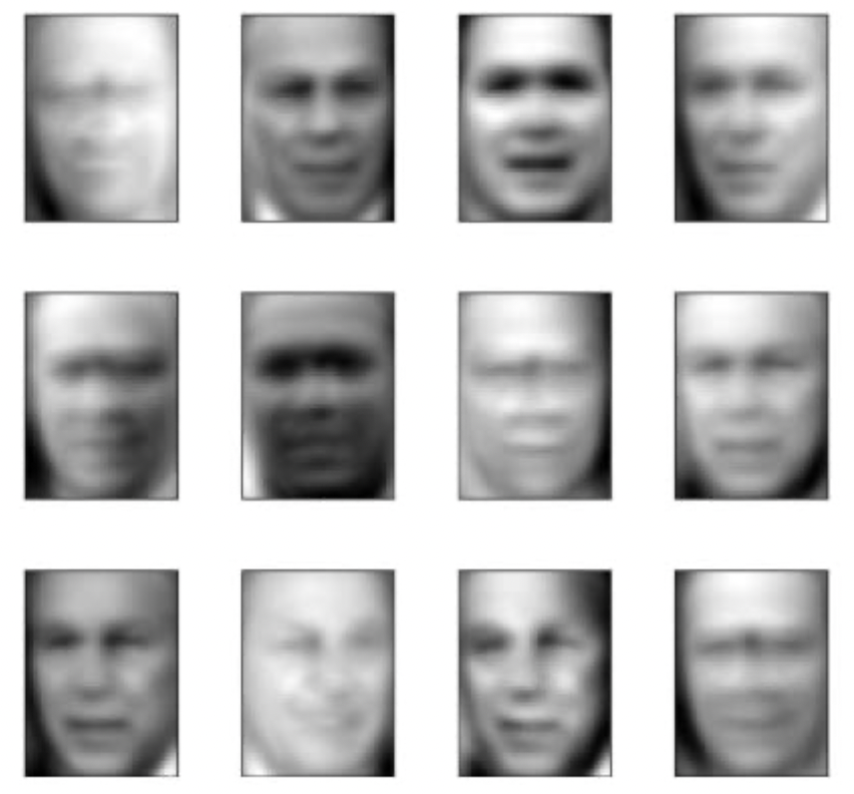

L = 50  
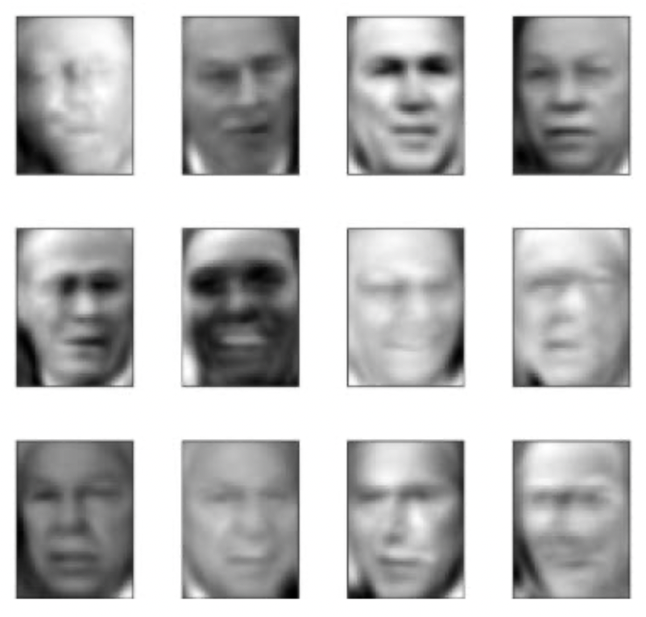  
  
 L = 100  
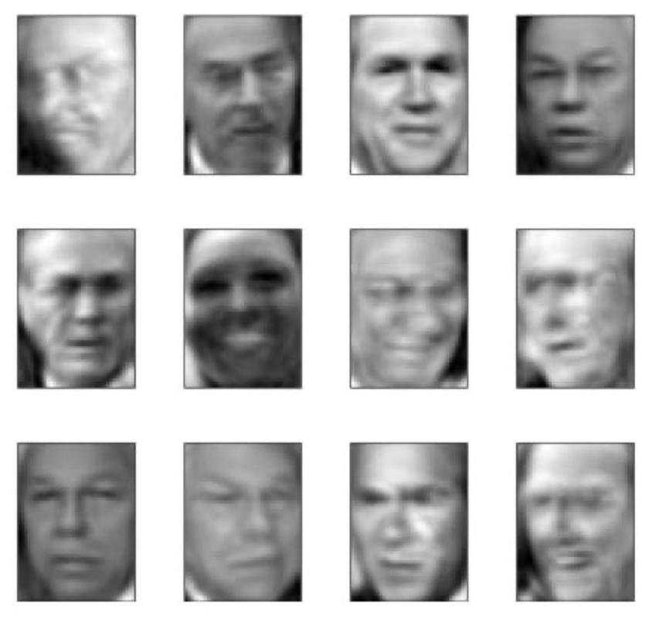

L = 500  
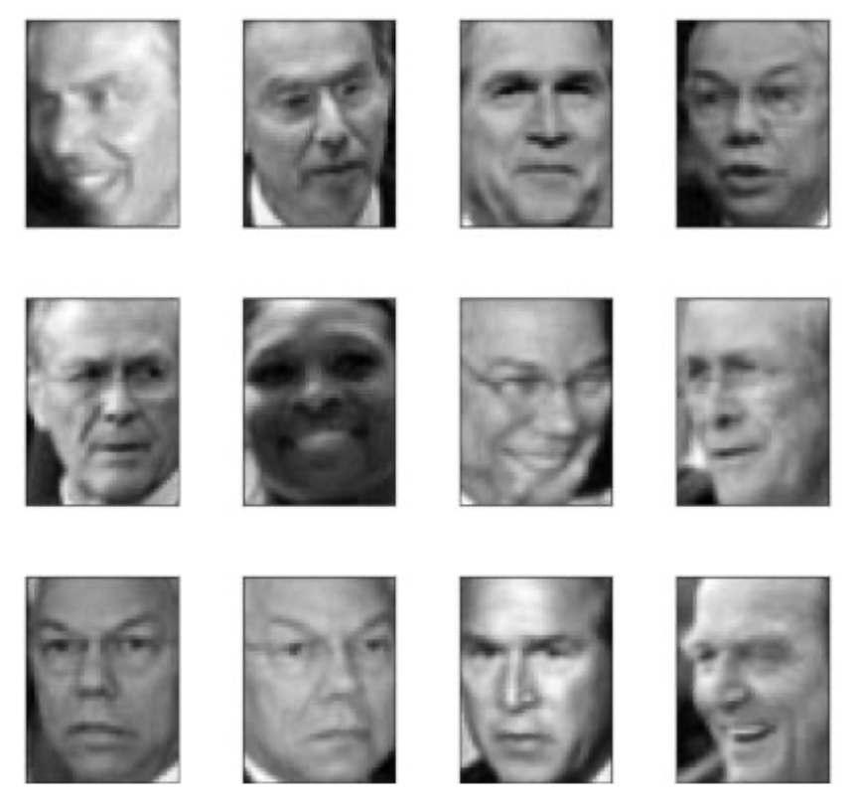  
  
 L = 1288  
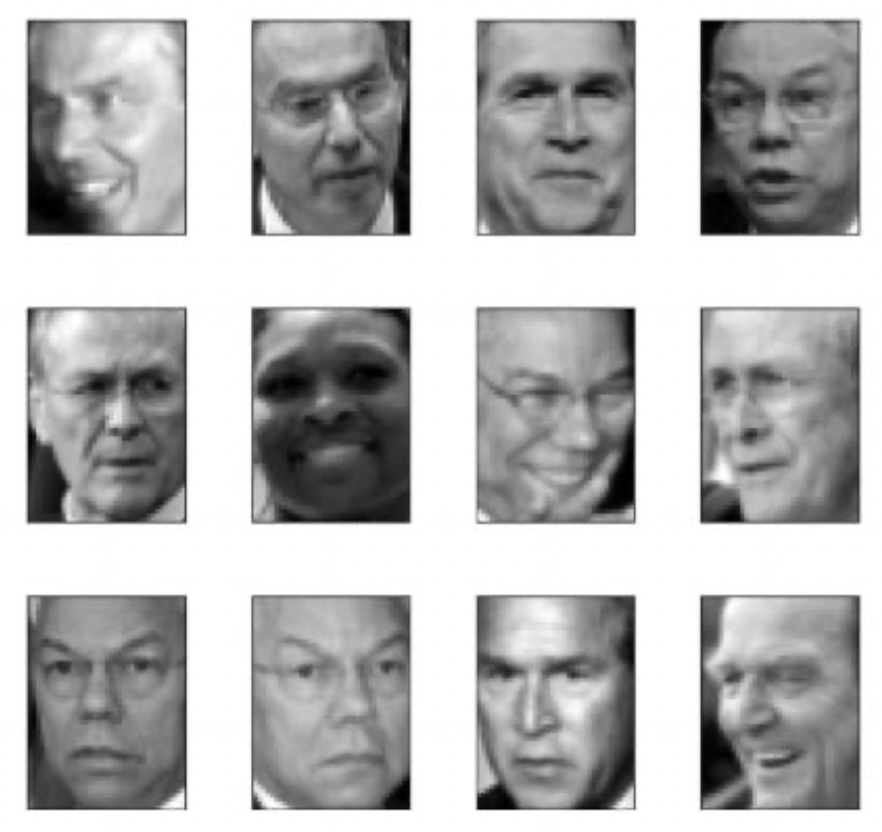As we increase the value of L, we see that the images start to become clearer and more distinguishable. At L = 50, the facial features become clearer and more identifiable and we can start to see the differences between the twelve eigenfaces. As we get to larger values of L, L > 100, L > 500 and L > 1000, the faces become extremely clear and recognisable. We noticed that much larger jumps in values of L should be used to get the slightest transformations in clarity.

1. a.   
   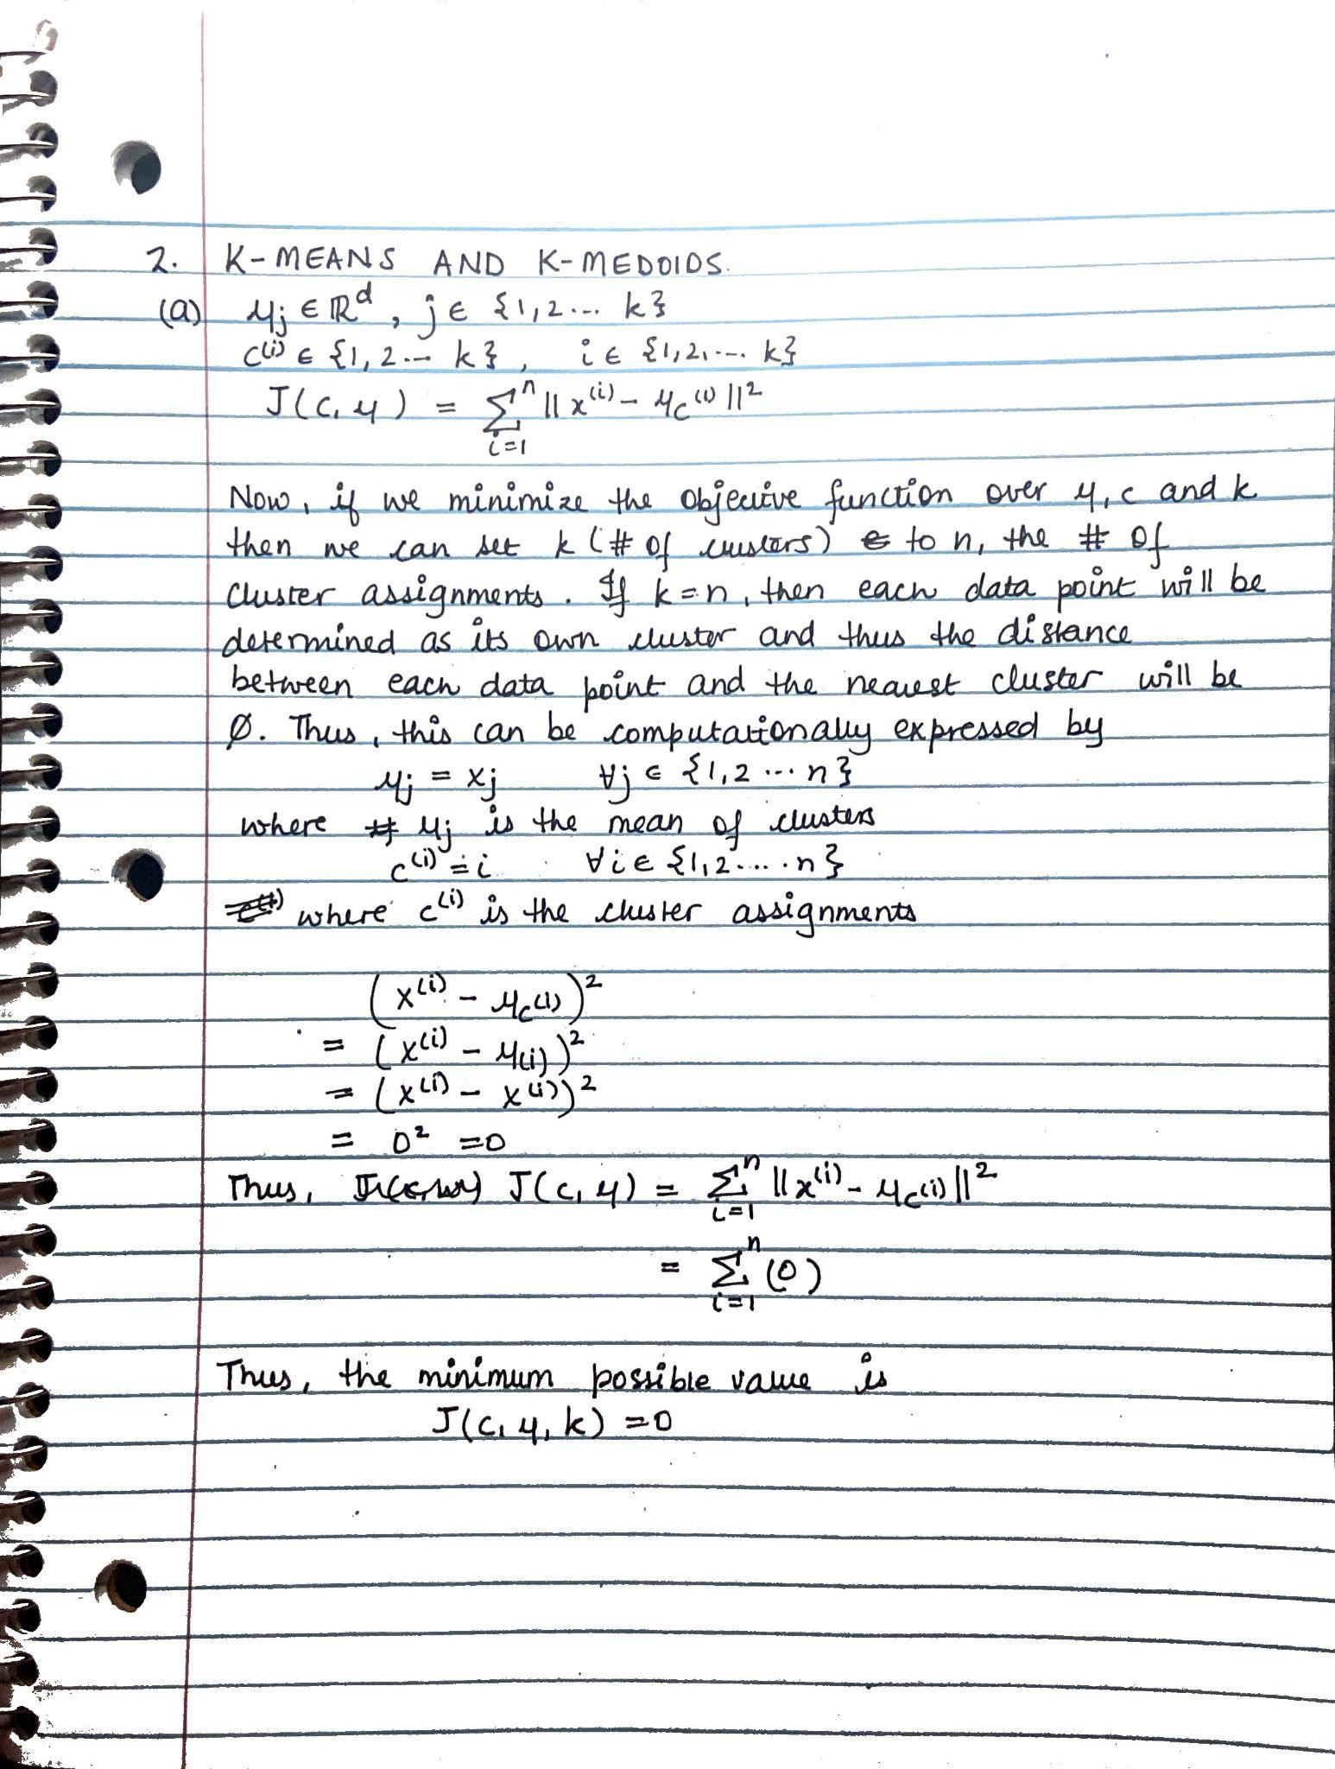  
   b.  
    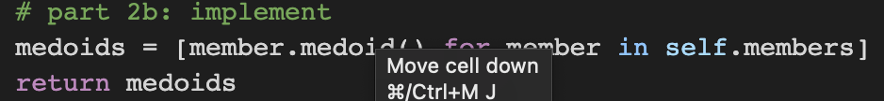  
     
   c.   
   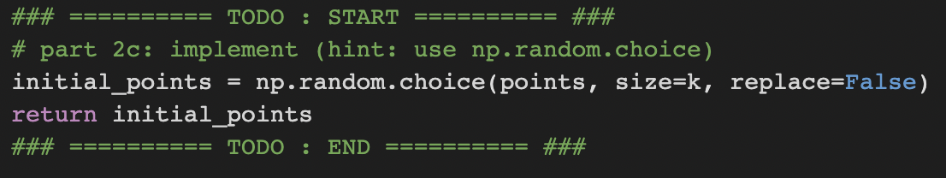  
     
   d.   
   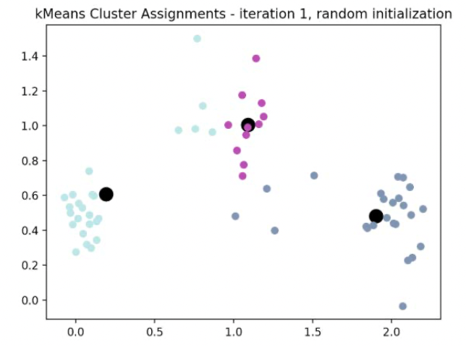  
   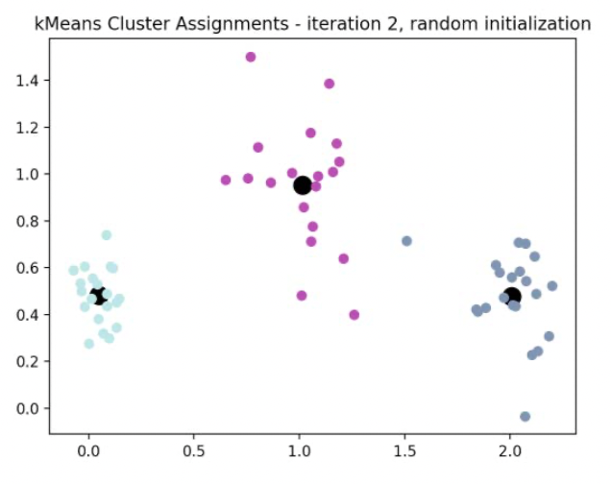  
   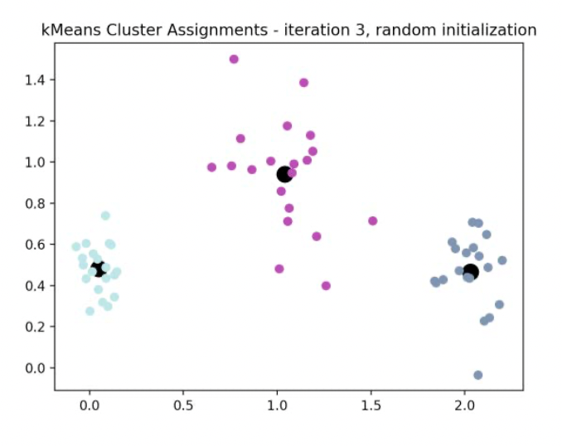  
   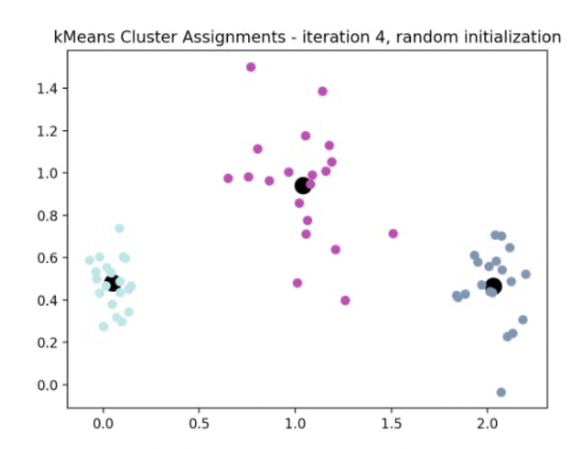  
     
   e.   
   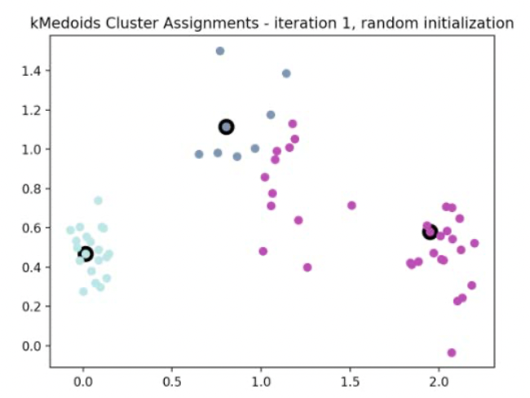  
   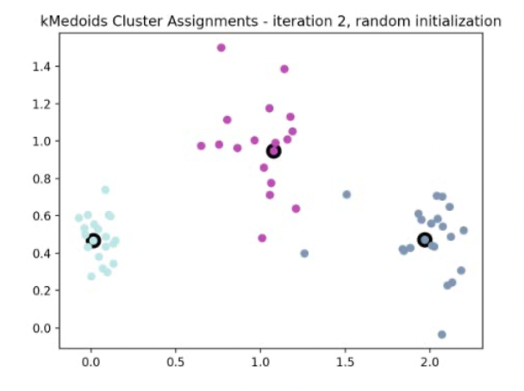  
   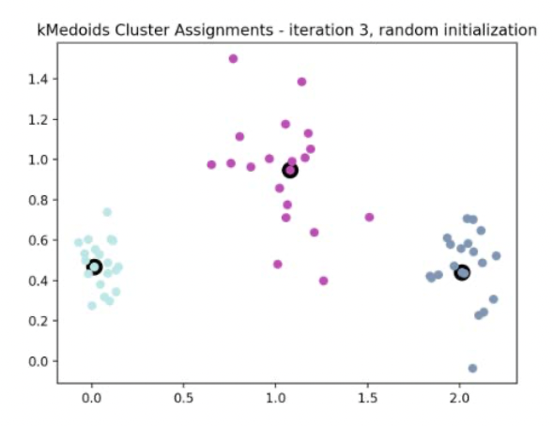  
   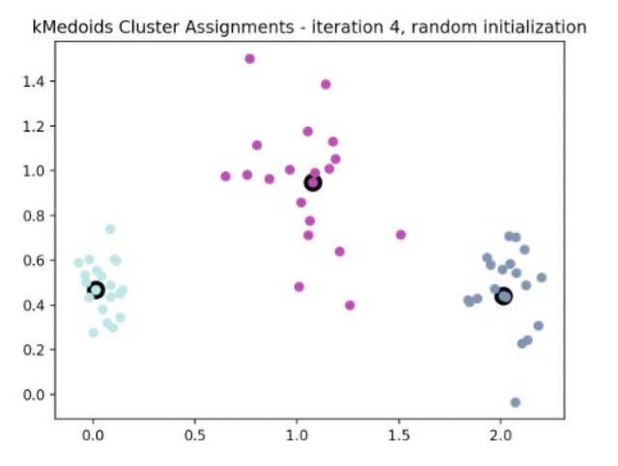

f.   
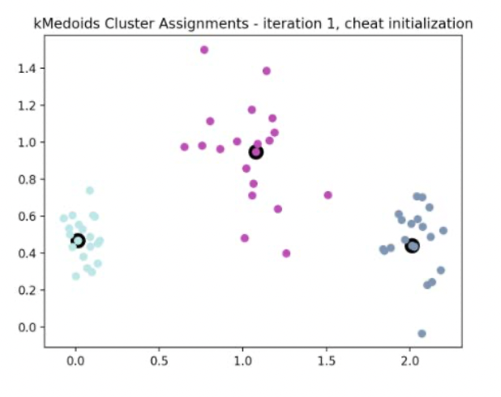  
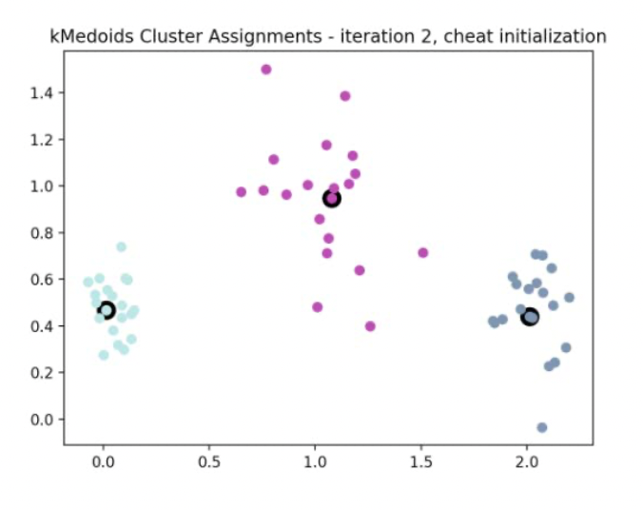

1. a.

|  | Average Purity | Minimum Purity | Maximum Purity | Average Time | Minimum Time | Maximum Time |
| --- | --- | --- | --- | --- | --- | --- |
| k-means | 0.6175 | 0.55 | 0.775 |  |  |  |
| k-medoids | 0.6325 | 0.575 | 0.725 |  |  |  |

b.   
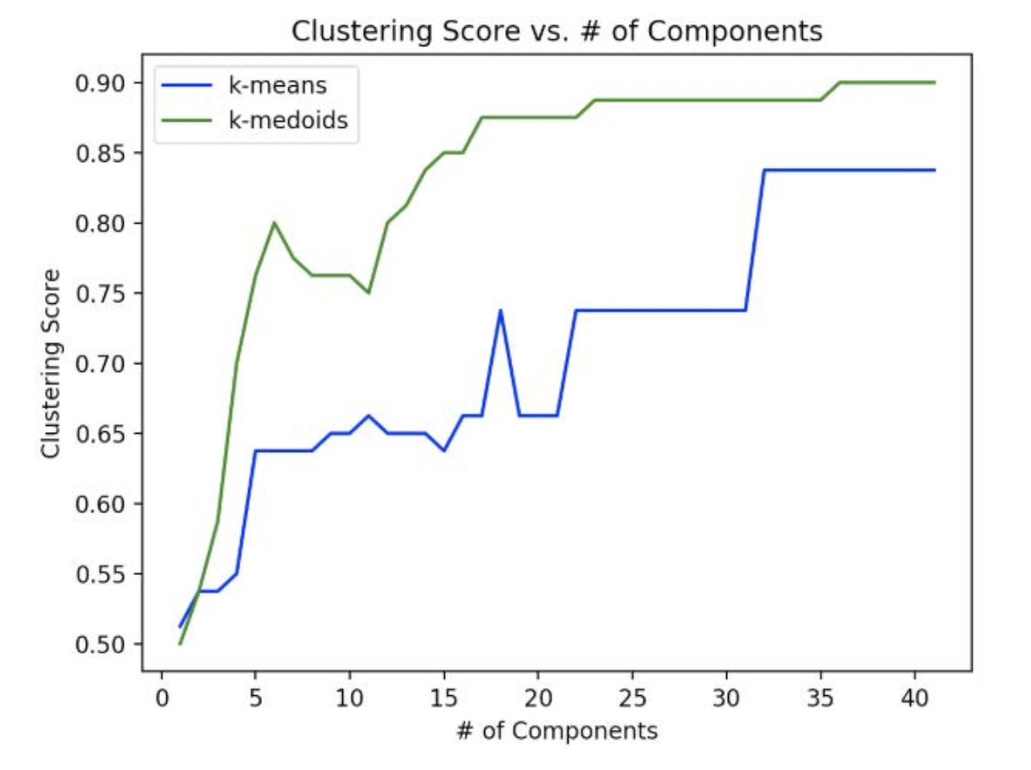  
  
For both k-means and k-medoids, we notice that the cluster score increases gradually as the number of components increases. The increase for both is not perfectly linear as we see there are a lot of jumps and falls. This indicates that a larger number of components does not necessarily correlate to a higher clustering score. However, the general trend shows that more components will lead the algorithm to distinguish the data points into separate clusters, thus producing a higher clustering score. Additionally, we see that the plots begin to level out around 17 components for the k-medoids and around 32 for the k-means. More so, the k-medoids algorithm has better performance than the k-means algorithm, which is because medoids are restricted to be actual members of the data set while means are the average of the data points in a cluster. K-medoids is more robust as it is not as sensitive to outliers as k-means, leading to improvement of performance of the algorithm.   
  
c. Pairing that clustering found difficult to discriminate were Label 4 and Label 5  
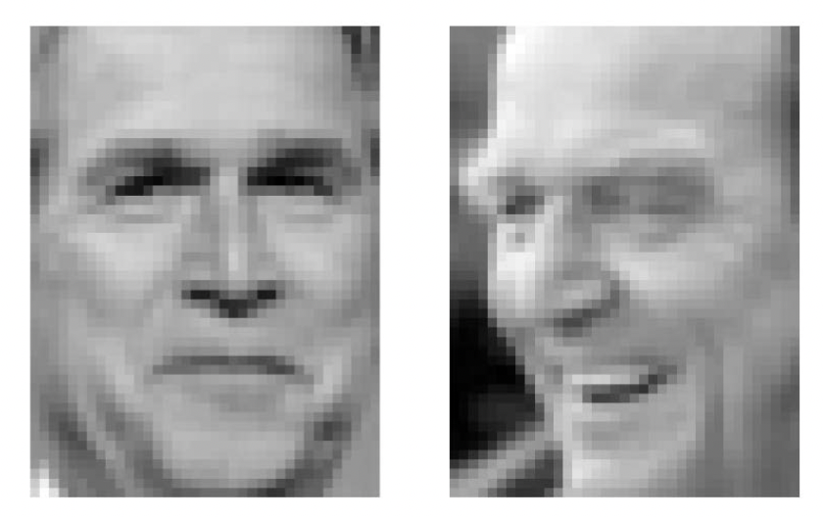  
Clustering score = 0.5125  
  
Pairing that cluster found easy to discriminate were Label 9 and Label 16  
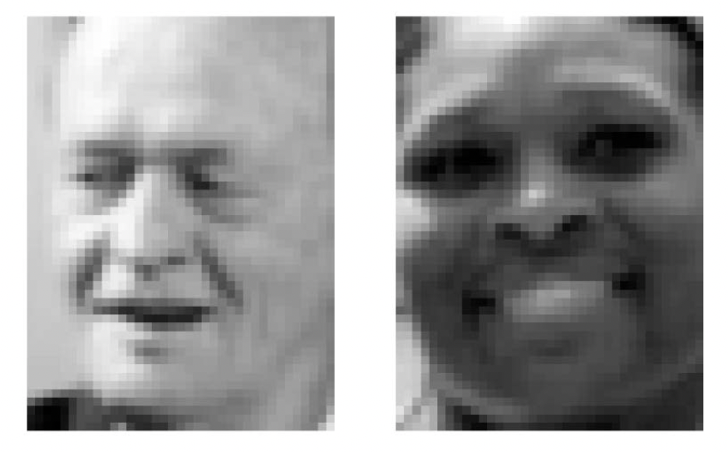  
Clustering score = 0.9875

To find pairs that clustering can discriminate with very well and one that it finds it difficult to discriminate, we employed nested for loops to compare the 40 photos that are not the same photo. If two photos were different, we would use the build_face_image_ponts to translate these images to labeled points. Using the labeled points, we would then run k-medoids algorithms with k = 2 clusters. Using the score() function in cluster.py, we would then compute the cluster score of the medoid clusters. Still iterating, we would get the max and min cluster scores along with the associated labels of both photos and store them in a variable that can be used outside the nested for loops. Once we had the max and min scores, we used the plot_representative_images function to plot the images for the labels.